**Palliser Regional Schools**

**Palliser Centre**

#101, 3305 - 18 Avenue North, Lethbridge, AB T1H 5S1

Phone: 403-328-4111 Toll-free: 877-667-1234

Fax: 403-380-6890 www.pallisersd.ab.ca

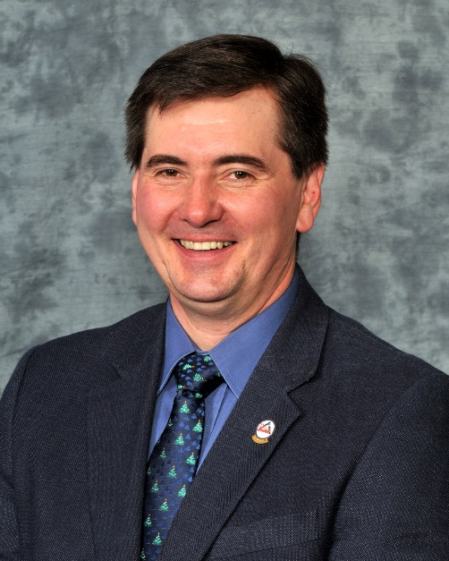

November 2015

Every student can be a leader

Hello everyone,

While I’m the first person to talk about student achievement, academic results and data, this month I want to focus on something that’s more difficult to measure but invaluable to our students. Leadership.

On Nov. 20 in Lethbridge, Palliser will hold its second annual Student Leadership Conference. Last year’s spring event was our first attempt to bring our students together for a day of inspiration and sharing. Out of that event, we identified a core group of high school students who have been part of a committee planning this year’s event. They came up with our theme, “Discovering U: Explore. Create. Achieve” and they will be leading this year’s conference. Their goal will be to help give their peers from Grades 7-12 the confidence and tools to be agents for change in their own schools and communities.

We’re hoping more than 400 students from across Palliser will participate in this year’s event, to hear keynote speaker, musician, author and entrepreneur David Usher, attend breakout sessions and work in school teams to develop a plan for action. The key will be for students to unleash their own genius and passion for the benefit of others.

Throughout the year, we look for ways to learn from our students and their experiences in our schools. We hold focus group meetings with students when we review a school. I try to attend these sessions personally because the students always prove insightful.

We saw many students participate in last springs “A Community Conversation 2015,” a division-wide stakeholder meeting, and feedback from the day was overwhelmingly positive about the input students provided.

Several of our schools are or are becoming Leader in Me Schools, embracing a student leadership program based on the Seven Habits of Highly Effective People and the belief every child can be a leader.

A committee of our principals has begun work on a student leadership event for students in Grades 4-6, and we had several schools participate in We Day recently.

Daily we see our students of all ages demonstrating leadership with their peers and in their communities.

I truly believe between literacy skills for critical thinking and analysis and leadership development, we can help give our students the tools for success wherever life takes them.

Kevin Gietz, Superintendent

Palliser Regional Schools