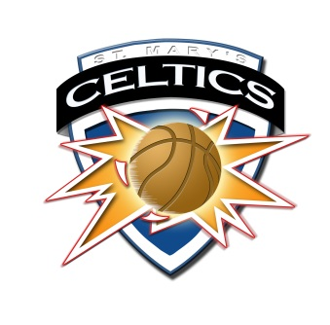
St. Mary’s Taber
Celtics Invitational Basketball Tournament
Jan 19 & 20, 2018

Nobleford
2:30 pm
Game 1
Friday
2:00 p

Game 5 Stirling Game 7
8:00 am Kate Andrews 11:30 am
4:15 pm
Game 2
Friday

Sat. Sat.

Game 10
FP Walshe Game 12
4:45 pm St. Mary’s 8:15 pm
4th Erle Rivers Sat. 1st
6:00 pm
Game 3
Friday
Sat.
Game 8
Game 6 Crowsnest Pass 1:15 pm
9:45 am St. Mike’s (PC) Sat.
7:45 pm
Game 4
Friday
Sat.

Picture Butte
Game 9
3:00 pm
Game 11
6:30 pm

8th 7th 7th 5th 3^{rrd}

